Coffee with Coordinators – Stop by on September 10!
September 8, 2025
Dear Assessment Coordinators,

We hope your Fall 2025 semester is off to a great start! As you work through your 2024-25 assessment reports due September 30, we hope you’ll take a moment to join us for a cup of coffee and a snack.

Stop by on September 10 from 10-11 a.m. in the OEE Conference Room, N3070 Melville Library, to chat with fellow coordinators, ask your assessment questions, and grab a cup of joe to jumpstart your day!

Register here: https://forms.gle/cZnUjBGjUXHCWRyt5

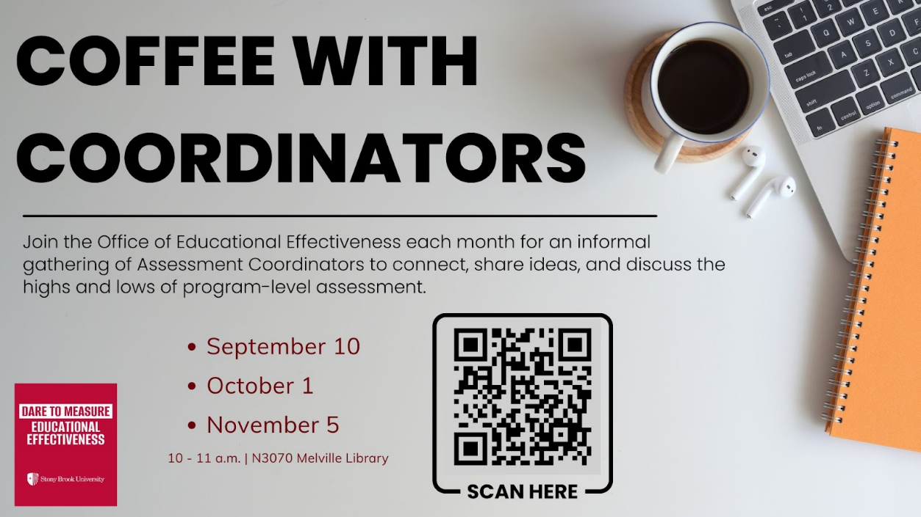

Best,
Office of Educational Effectiveness
Office of the Provost
EducationalEffectiveness@stonybrook.edu
OEE Website


